Technical Datasheet WIN-SN-TnH-IAQ-W-D Sensor

The Sensor Unit collects the environmental data of 3 parameters from the indoor surrounding and displays the data as well as sends the data to the Cloud over MQTT protocol over WI-FI.The unit is robustly designed for continuous 24/7 operation and is exceptionally easy to use.

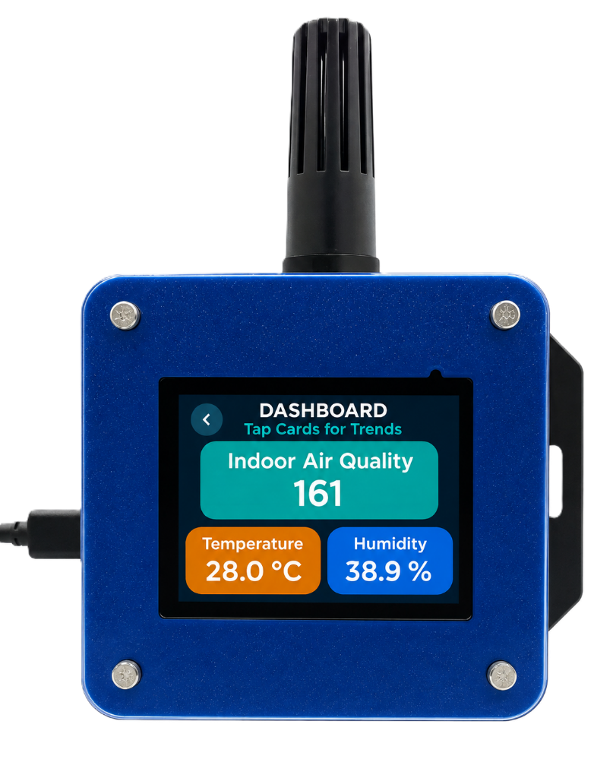
Display Module: -
The module is housed in a rugged industrial enclosure with wall mounting slots featuring an integrated display for easy installation deployment. Configuration settings such as Wi-Fi connectivity, MQTT parameters and cloud communication can be managed through the integrated display interface or the built-in web portal.
The modules are designed for reliable long-term operation with built-in protection, ensuring enhanced safety and system reliability. The Display Unit collects, displays, and securely publishes sensor data to the cloud using the MQTT protocol, enabling continuous remote monitoring and data access.
Specifications
General –
Dimensions 98 mm L x 98 mm B x 34 mm H
Power Input Power – 5 VDC Type C
Operating Temperature -20°C to +80°C (-4°F to +176°F)
Storage temperature -20°C to +80°C (-4°F to +176°F)

Storage Humidity 5 ~ 95 % RH, non – Condensing
Certifications

Operator Interface & Navigation Guide

1. Initial Network Provisioning (Wi-Fi Setup):
Upon first boot—or when a network change is required—the device enters Access Point (AP) mode. The screen displays a "Wi-Fi Setup Required" prompt, broadcasting its own local network. Users simply connect to this network via a mobile device or laptop using the Password 12345678 and navigate to the provided IP address (ex: 192.168.4.1) to securely pass local Wi-Fi credentials to the unit.
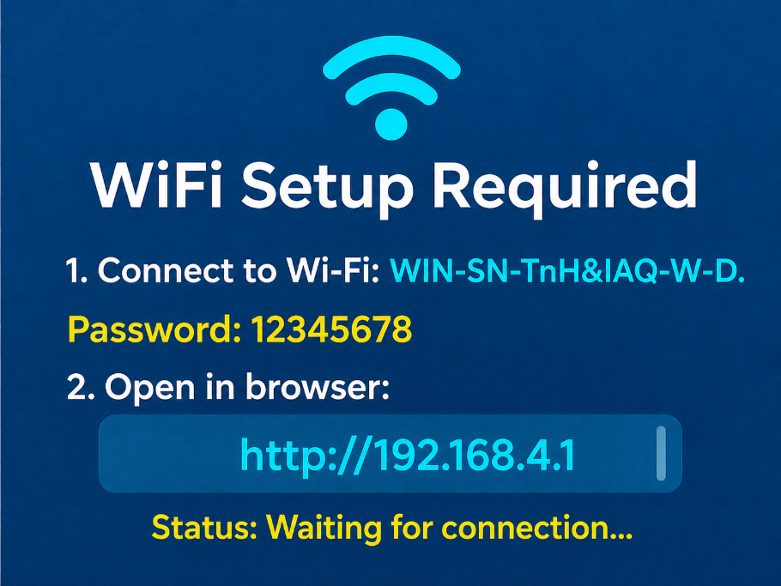

2. Home Screen & Main Navigation
Once provisioned, the device boots to the Home Screen, displaying the company logo, current date/time, and system title. Tapping the [ > ] icon in the top right corner opens the Main Menu, which splits the interface into two primary pathways:
- Dashboard: For live data of the sensors.
- Local Trends: Displays historical trend graphs for each monitored parameter (Temperature, Humidity, and IAQ). Users can independently select 6-hour, 12-hour, or 24-hour trend data for each parameter.
- MQTT Dashboard: Indicates the current cloud connection status (Connected/Disconnected)
- WiFi Settings: Configure the device whenever the Wi-Fi network changes
- MQTT Setup: Configuration settings for the MQTT Connections

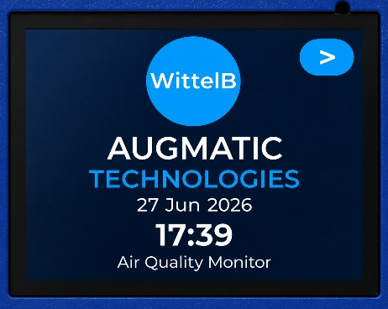
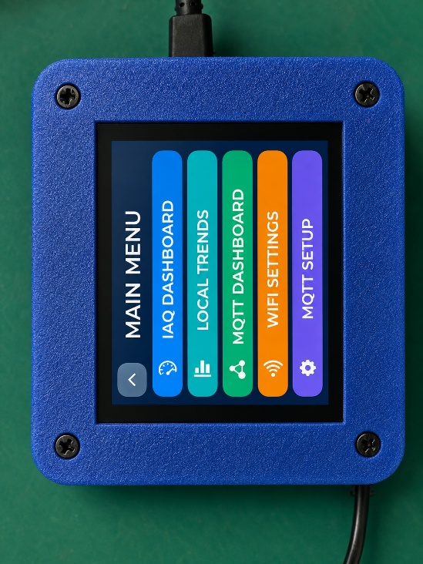

3. Live Telemetry Dashboard
The Dashboard provides a clear, real-time view of all monitored parameters on a single screen, enabling users to quickly assess the current environmental conditions.
- Real-Time Monitoring: Displays the latest values of all connected sensors, including Temperature, Humidity, IAQ
- Color-Coded Display: Each parameter is presented in a dedicated color-coded tile for improved readability and quick identification.
- Instant Data Updates: Sensor readings are refreshed continuously, providing up-to-date information for effective environmental monitoring.
- User-Friendly Interface: The intuitive display allows users to easily view and monitor all air quality parameters from a single dashboard screen.

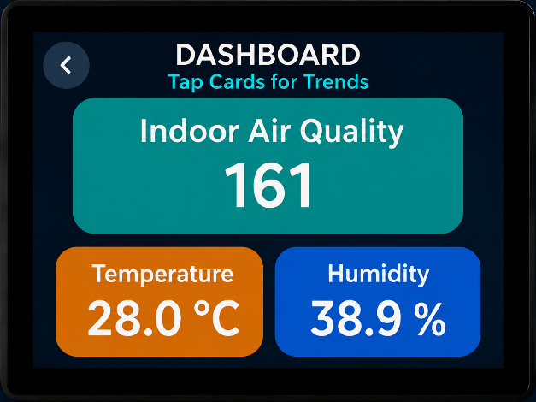

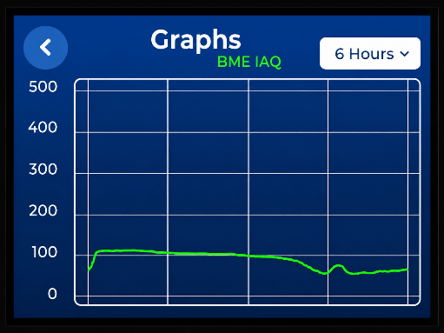
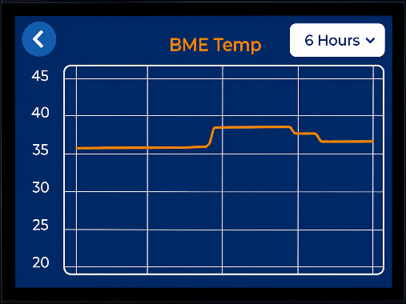
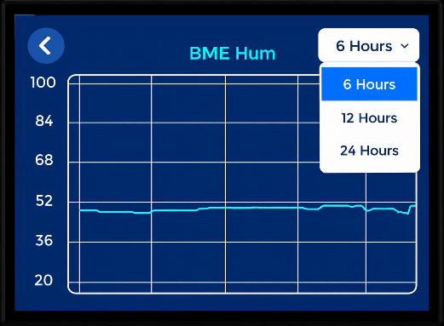
4. Local Trends
Image-1 Image-2 Image-3

- Live Trend Monitoring: View real-time graphical data for Temperature, Humidity, and IAQ, enabling continuous monitoring of environmental conditions.
- Individual Parameter Analysis: Each parameter (Temperature, Humidity, and IAQ) can be viewed independently with its own dedicated trend graph.
- Selectable Time Range: Users can choose 6-hour, 12-hour, or 24-hour historical data for each parameter individually to analyze short-term and long-term trends.
- Default Time Range: By default, the trend graph displays the last 6 hours of data. Users can change the view to 12 hours or 24 hours for each parameter individually.
- CSV Data Export: Download historical data in CSV format for the selected parameter and selected time range (6 Hours, 12 Hours, or 24 Hours) for offline analysis, reporting, and record keeping.

Web Portal Configuration Guide (Air Quality Monitor)

The embedded web portal provides a unified, single-page interface for configuring both local Wi-Fi credentials and MQTT cloud telemetry settings. This streamlines setup and enables seamless remote sensor data monitoring.

1. Accessing the Settings
- Ensure you are connected to the device's network and enter the device's assigned IP Address (e.g., 192.168.1.41) into your web browser.
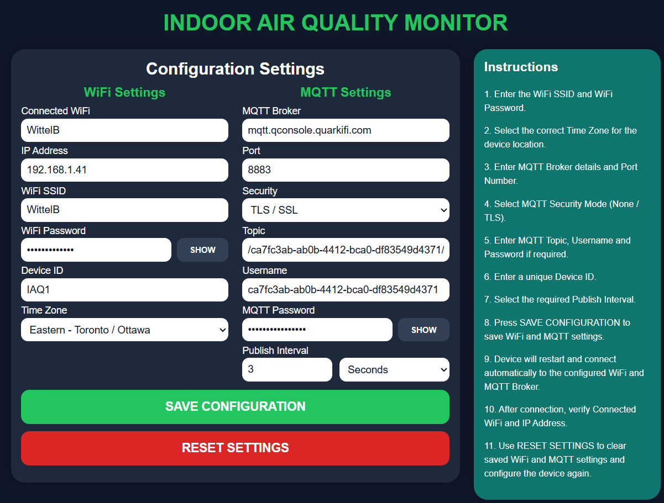
- You will be directed immediately to the unified Configuration Settings page.
2. Network & Localization Settings
- Enter your local network credentials into the WiFi SSID and WiFi Password fields.
- Select the correct Time Zone for the device's physical location from the dropdown menu to ensure accurate data timestamping.

3. MQTT Cloud Configuration
- Enter your MQTT Broker address and Port number.
- Select the required Security mode (None or TLS / SSL).
- Provide your designated Topic, Username, and MQTT Password (if your broker requires authentication).
- Assign a unique Device ID (e.g., IAQ1).

4. Data Transmission & Saving
- Set your desired Publish Interval and select the time unit (Seconds or Minutes).
- Click the green SAVE CONFIGURATION button.
- The device will automatically restart, save the parameters, and connect to the configured Wi-Fi and MQTT broker.
- Verification: Once reconnected, you can verify a successful network bridge by checking the read-only Connected WiFi and IP Address fields at the top left.

5. Factory Resetting Network Parameters
- If you need to move the device to a new network or clear the current cloud configuration, click the red RESET SETTINGS button. This will wipe all saved Wi-Fi and MQTT data, allowing you to configure the device from scratch.

Instructions:
- Connect the device to a Wi-Fi network and verify that a valid IP address is assigned.
- Enter the MQTT Broker address and Port number.
- Select the required Security mode (None/TLS).
- Enter the MQTT Topic, Device ID, Username, and Password (if authentication is enabled).
- Set the desired Publish Interval and select the time unit (Seconds or Minutes). The device will automatically publish sensor data to the MQTT cloud at the selected time interval.
- Click SAVE CONFIGURATION to store the settings.
- The device will automatically restart and reconnect using the new configuration.
- The default MQTT publish interval is 5 seconds.
- The display refreshes sensor readings every 2 seconds to provide near real-time monitoring.
- IAQ, sensor require approximately 5 minutes of warm-up time after power-up before providing readings.
- Verify the cloud connection status to ensure sensor data is being published successfully.

Contact us: -
Augmatic Technologies Pvt. Ltd.,
Plot no 6, Shah Industrial Estate II,
Kotambi,
Vadodara – 391510.
Email – Sales@wittelb.com
Support: support@wittelb.raiseaticket.com / +91 94038 92805

